Write a MapReduce/Pig program to calculate the number of cases investigated under each

FBI code

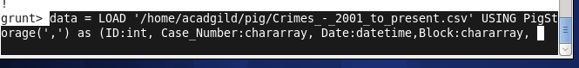

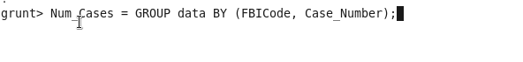

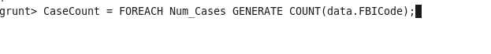

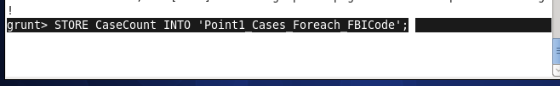

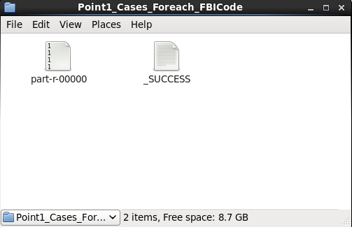

Above files has been attached in github

2. Write a MapReduce/Pig program to calculate the number of cases investigated under FBI

code 32.





